Adarsh Rana

20711150

MCA 3C

1. Write a program to create an item collection and clones the items using AngularJS directives.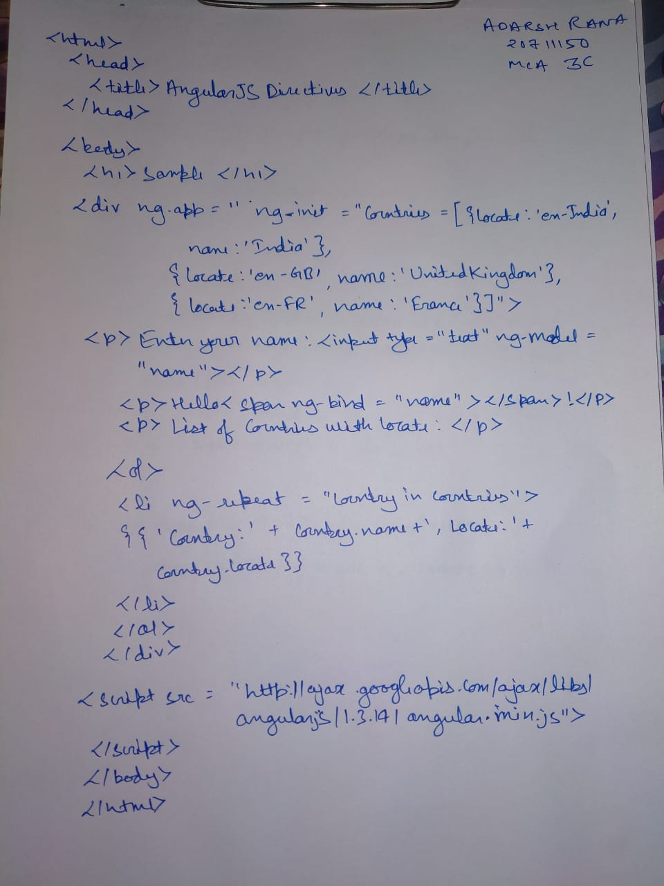

OUTPUT

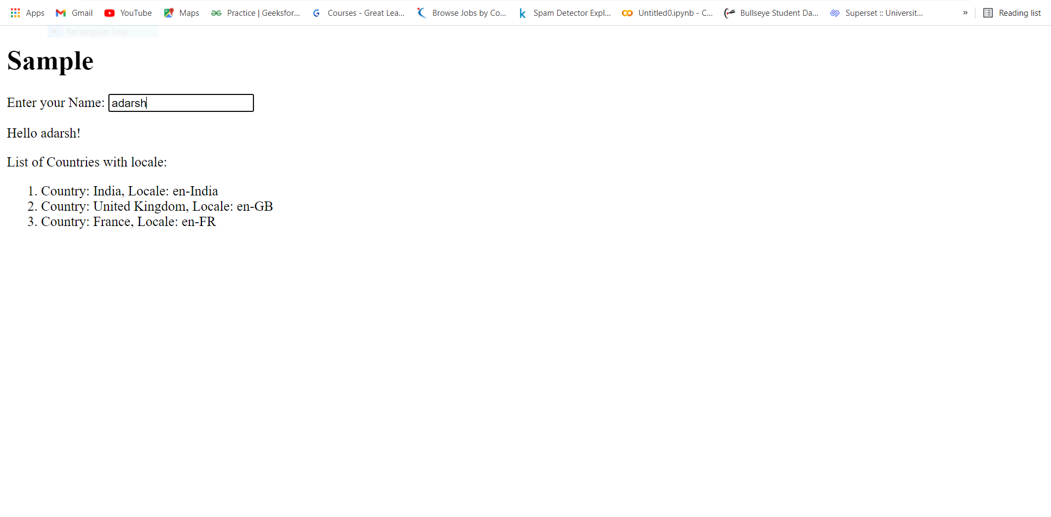

1. Write a program to create an HTTP server which can communicate between client and the server.

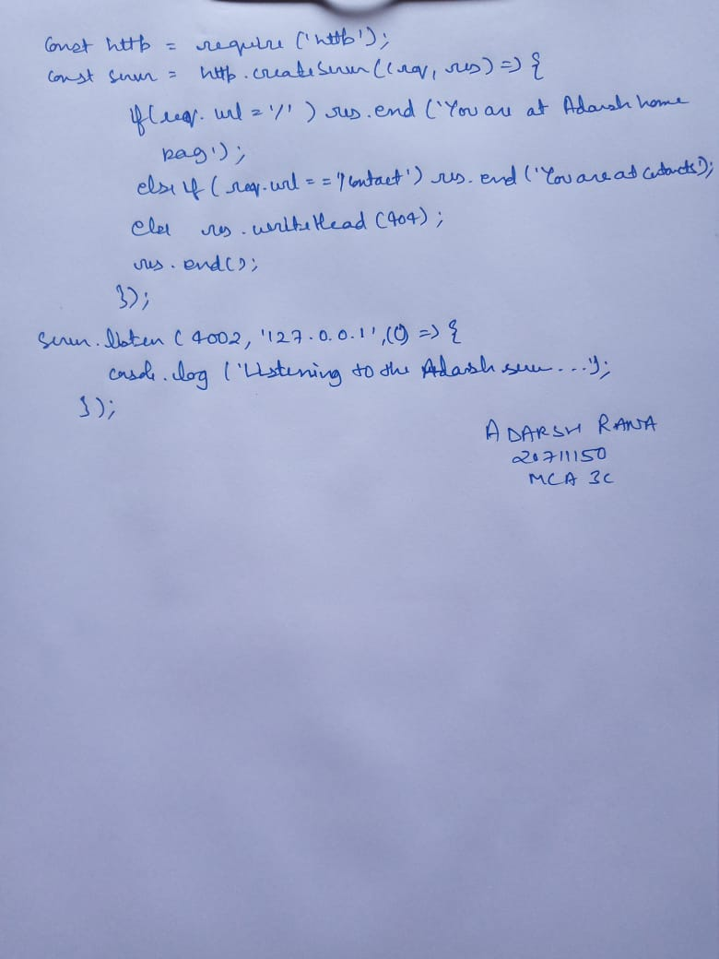

Output

